2024 Node.js mimi problem
To find out what MIME version that you are using, enter:
npm list mime

If you are using MIME version 4.0, then the existing MIME cannot use the require() function.
You need to use the previous version of MIME such version 3.0.0

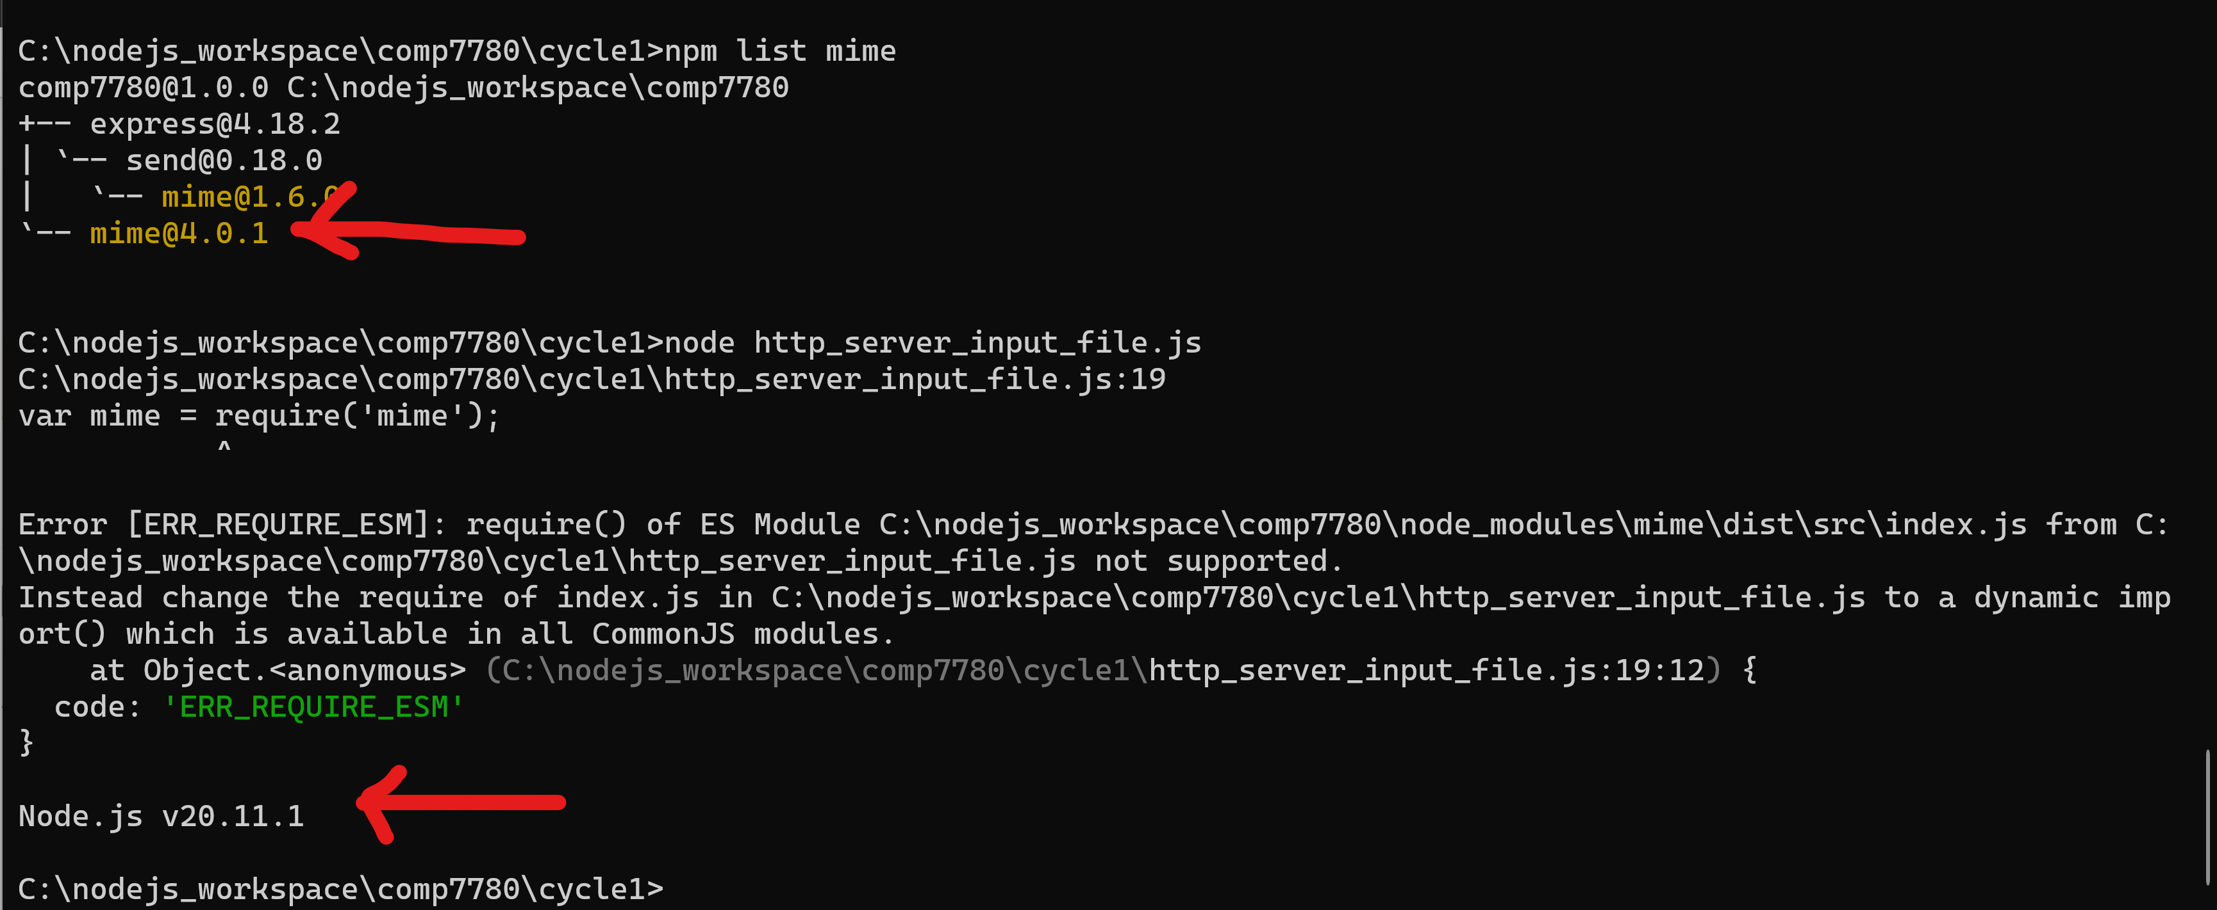

To fix this problem, you need to install version 3.0 of MIME. Enter:
npm install mime@3.0.0
Then, make sure that you are using MIME version 3.0.0
Then, execute http_server_input_file.js

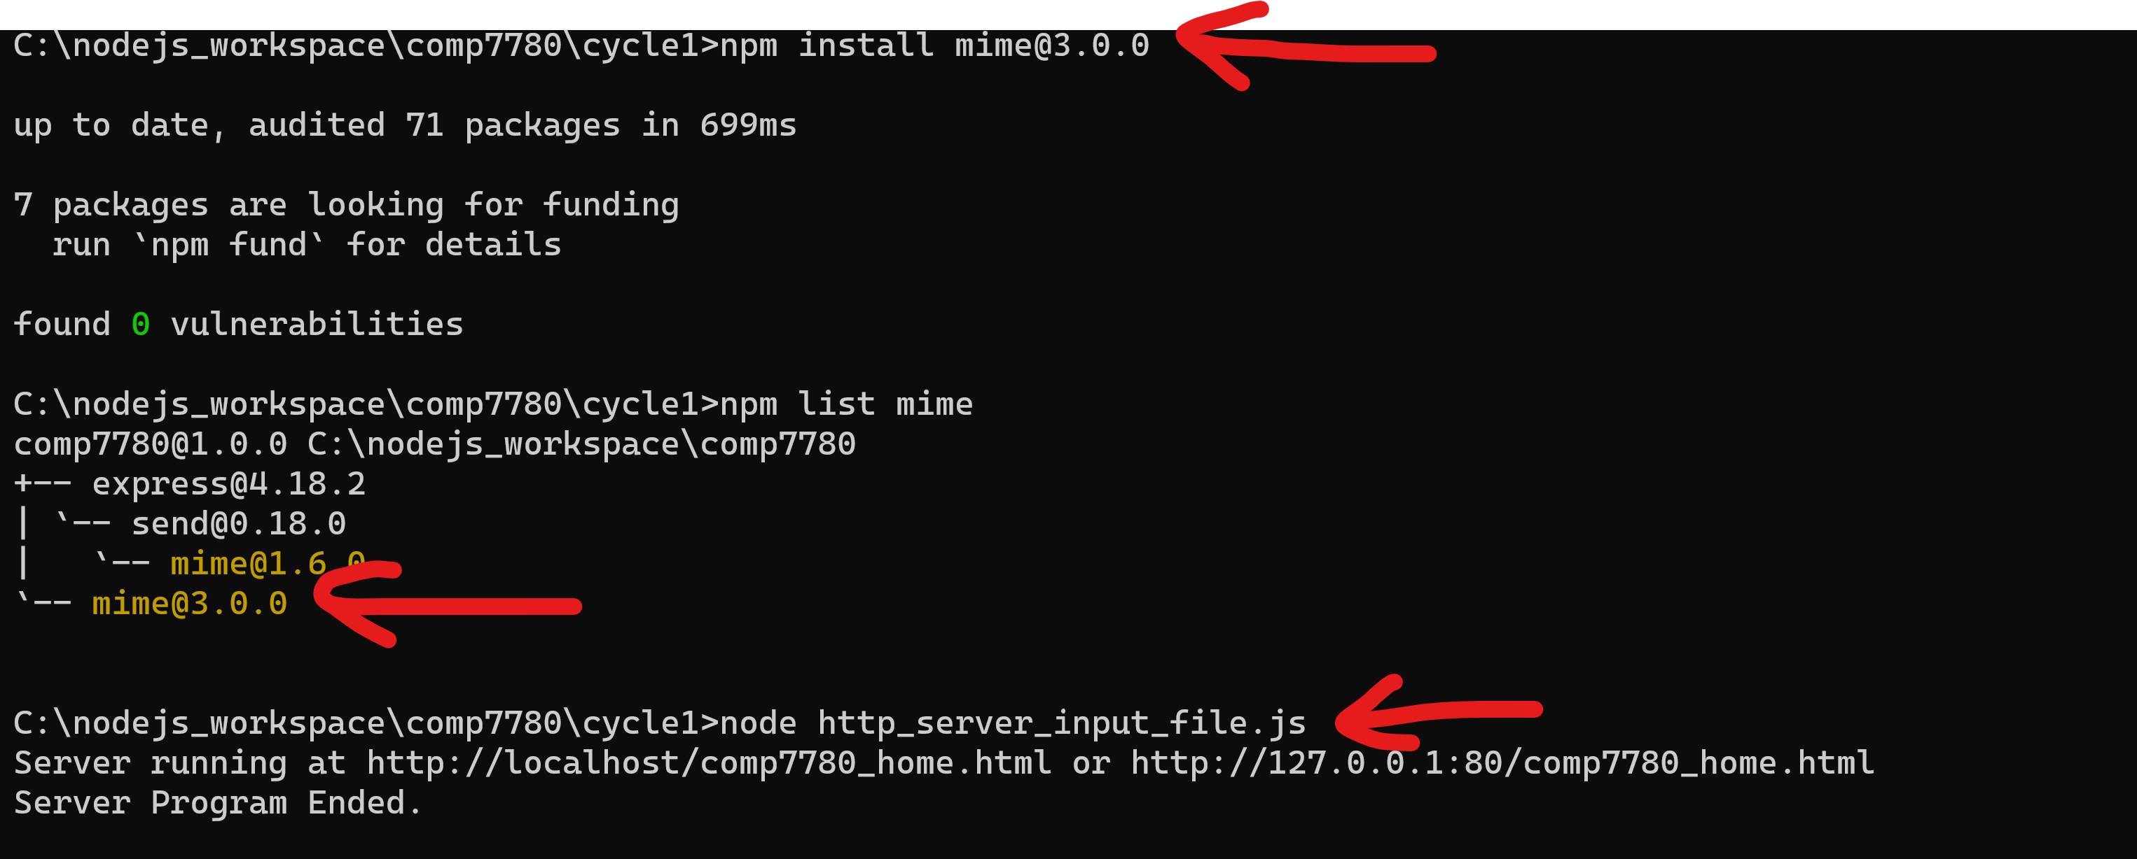

To cancel the node web server. Enter:
CTRL C

